PROCESSES IN OPERATING SYSTEMS

1. Introduction to Processes
A process is a program in execution. It represents the basic unit of work in a modern computing system. Understanding how a program transforms into a process and how it executes is fundamental to operating systems.

1.1 What is a Process?
A process consists of:
- Program Code (Text Section)
- Current Activity (Program Counter, Processor Registers)
- Stack (Temporary Data - function parameters, return addresses, local variables)
- Data Section (Global Variables)
- Heap (Dynamically allocated memory during runtime)

Diagram 1: Process Memory Structure
STACK (Function calls, local variables, parameters)
↓ Stack grows downward
HEAP (Dynamically allocated memory)
↑ Heap grows upward
DATA SECTION (Initialized global & static variables)
TEXT/CODE SECTION (Executable instructions)

1.2 Program vs Process
Aspect | Program | Process
Nature | Passive entity | Active entity
Location | Stored on disk | Loaded in memory
Lifespan | Permanent (until deleted) | Temporary (while executing)
Resource Usage | Disk space only | CPU, memory, I/O devices
Multiplicity | One file | Multiple instances possible

2. How a Program Resides on Hard Disk
When a program is stored on a hard disk, it exists as an executable file. This file contains all the necessary information to create a process when executed.

2.1 Executable File Format
Common executable formats include:
- EXE (Windows Executable)
- ELF (Executable and Linkable Format - Linux/Unix)
- Mach-O (macOS)

2.2 Components of Executable File
- Header: Contains metadata about the program (entry point, architecture, etc.)
- Code Section: Contains the compiled machine code instructions
- Data Section: Contains initialized global and static variables
- BSS Section: Contains uninitialized global and static variables
- Symbol Table: Information for debugging and linking

Diagram 2: Program Storage on Hard Disk
EXECUTABLE FILE (e.g., program.exe)
HEADER Magic number, entry point, architecture info
CODE/TEXT SECTION Compiled machine instructions
DATA SECTION Initialized global/static variables
BSS SECTION Uninitialized global/static variables
SYMBOL TABLE & DEBUG INFO Function names, variables, line numbers

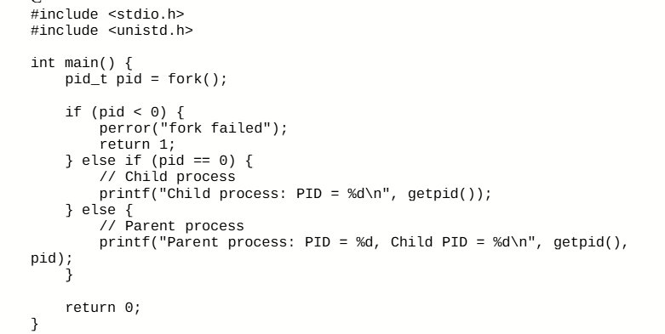

Memory Section | Code Elements Mapped | Runtime Behavior
Stack | Local variable pid | Created when main() is called, contains local variables and function call information
Heap | None (no dynamic allocation) | Would contain malloc() allocations if present
.bss | None | Empty section for uninitialized globals
.data | None | Empty section for initialized globals
.rodata | String literals:  "fork failed"  "Child process: PID = %d\n"  "Parent process: PID = %d, Child PID = %d\n" | Read-only, shared between parent and child processes
.text | Entire main() function:  1. fork() call  2. if-else logic  3. printf() calls  4. getpid() calls  5. return statements | Read-only executable code, shared between parent and child
ELF Header | Program metadata | Loaded by OS to set up process  (Executable and Linkable Format) (ELF) header

3. From Program to Process: The Transformation
When you execute a program, the operating system performs several steps to transform the passive program file into an active process.

3.1 Process Creation Steps
- User Initiates Execution: Double-click, command line, or system call
- Load Executable into Memory: OS reads executable file from disk and loads it into RAM
- Memory Allocation: OS allocates memory for code, data, stack, and heap
- PCB Creation: Process Control Block is created with process metadata
- Initialize Process State: Set program counter to entry point, initialize registers
- Add to Ready Queue: Process is placed in ready state, waiting for CPU

Diagram 3: Process Creation Flow
User executes program (double-click/command)
↓
OS locates executable file on disk
↓
Loader reads file into memory
↓
OS allocates memory (stack, heap, data, code)
↓
Create Process Control Block (PCB)
↓
Initialize registers, program counter
↓
Add process to Ready Queue
↓
Process waits for CPU scheduling

4. Process Control Block (PCB)
The Process Control Block is a data structure maintained by the operating system for every process. It contains all the information needed to manage the process.

4.1 PCB Components
PCB Field | Description | Example
Process ID (PID) | Unique identifier for the process | Parent: 1000  Child: 1001
Process State | Current state (New, Ready, Running, Waiting, Terminated) | Parent: Running → Ready (when waiting for child)  Child: New → Ready → Running → Terminated
Program Counter | Address of next instruction to execute | 0x400510 (address of printf("Child..."))  Example: Child's PC points to first instruction after fork()
CPU Registers | Contents of all processor registers | RAX: 1001 (fork return value in parent)  RAX: 0 (fork return value in child)  RBP: 0x7ffffffee240 (stack frame pointer)  RSP: 0x7ffffffee230 (stack pointer)
Memory Management | Page tables, segment tables, memory limits | Page Table Base: 0x8000  Text Segment: 0x400000-0x400fff (read-only)  Data Segment: 0x600000-0x600fff  Stack Limit: 0x7fffffff0000
Scheduling Info | Priority, scheduling queue pointers, time quantum | Priority: 120 (normal priority)  Time Quantum: 100ms  Queue Pointer: Ready queue position 5
I/O Status | List of open files, I/O devices allocated | 0: stdin (terminal)  1: stdout (terminal)  2: stderr (terminal)  Open Files: /dev/tty1
Accounting Info | CPU time used, time limits, process creation time | Creation Time: 14:30:25.123456  CPU Time Used: 12.5ms

5. Process States and Life Cycle
Throughout its lifetime, a process moves through different states from creation to termination.

5.1 Five-State Process Model
- New: Process is being created
- Ready: Process is waiting to be assigned to a processor
- Running: Instructions are being executed
- Waiting/Blocked: Process is waiting for some event (I/O completion, signal, etc.)
- Terminated: Process has finished execution

Diagram 4: Process State Transition Diagram
NEW (Process being created)
↓ Admitted
READY (Waiting for CPU)
↓ Scheduler Dispatch
RUNNING (Executing on CPU)
↓ I/O or Event Wait | ↓ Exit | ↓ Interrupt/ Time Slice
WAITING (Blocked on I/O) | TERMINATED (Process finished) | → READY ← (Back to queue)
↑ I/O Complete (Waiting → Ready)

5.2 State Transitions Explained
Transition | Explanation
New → Ready | Process creation complete, added to ready queue
Ready → Running | Scheduler selects this process for execution
Running → Ready | Time quantum expired or higher priority process arrives
Running → Waiting | Process needs I/O or waits for an event
Waiting → Ready | I/O completed or event occurred
Running → Terminated | Process completes execution or is killed

6. Process Execution
Once a process is in the running state, the CPU executes its instructions. The process may be interrupted, scheduled out, or complete its execution.

6.1 CPU Scheduling
The CPU scheduler determines which ready process should be executed next. Common scheduling algorithms include:
- First-Come, First-Served (FCFS)
- Shortest Job First (SJF)
- Priority Scheduling
- Round Robin (RR)
- Multilevel Queue Scheduling

6.2 Context Switching
When the CPU switches from executing one process to another, it performs a context switch. This involves:
- Saving the state (context) of the current process in its PCB
- Loading the state of the next process from its PCB
- Resuming execution of the new process

Diagram 5: Context Switching
Process P0 Executing |  | Process P1 Idle (Ready)
↓ Interrupt or Time Slice Expired
SAVE STATE OF P0 Save registers, PC, stack pointer to PCB of P0
↓
RELOAD STATE OF P1 Load registers, PC, stack pointer from PCB of P1
↓
Process P0 Idle (Ready) |  | Process P1 Executing

7. Process Termination
A process terminates when it completes execution or is explicitly killed. Upon termination, the OS performs cleanup operations.

7.1 Reasons for Termination
- Normal Exit: Process completed successfully
- Error Exit: Process encountered an error and terminated
- Fatal Error: Process performed illegal operation (division by zero, segmentation fault)
- Killed by Another Process: Process terminated by parent or operating system

7.2 Termination Process
- Process executes exit system call (voluntary) or receives termination signal
- OS deallocates all resources held by the process
- Memory pages are freed and returned to the system
- Open files are closed
- PCB is removed from process table
- Parent process is notified (if waiting)

Diagram 6: Complete Process Life Cycle
Program on Hard Disk Executable file stored
↓ User executes
NEW State OS creates process, allocates PCB
↓ Admitted to system
READY State In ready queue, waiting for CPU
↓ Scheduler dispatch
RUNNING State Executing on CPU
↓ Multiple possibilities
Possible Paths from Running:
• Time slice expired → READY
• I/O request → WAITING → READY
• Completion/Exit → TERMINATED
↓ Final cleanup
TERMINATED State Resources deallocated, PCB removed
↓ Complete
Process Removed System cleanup finished

